- If you try to access any method of an object, but the object is null; then you’ll get an Null Pointer Exception.
- Remember: in java we initialize an array using {} curly braces; not [] square brackets.
- Consider the following scenario:
  - I have 3 files:
    - Main.java
      - Contains the main method.
      - It has an object of type QuestionService
    - QuestionService.java
      - If has an array of objects.
      - Those objects are of type Question
    - Question.java
      - It is a normal class that contains some variables and getter, setter methods to build a question.
      - Like, id (int), question(String), options (String[]), answer (String)
  - Now, I implemented the toString() method inside Question class, so that whenever I print the object of type Question directly, it’ll print something meaningful instead of the default hashcode.
  - Then I compiled Main.java and ran this. But I couldn’t see the changes that I did inside Question.java.
  - When you compile a .java file, it’ll generate .class file of all those Class which are linked to the .java file (in our case, all Classes i.e. Main, QuestionService, Question are linked).
  - Let I run javac Main.java
    - Now, it’ll compile Main.java and create the Main.class file.
    - And it’ll check if there is QuestionService.class and Question.class already present.
    - If present, then don’t recompile those; otherwise compile those as well.
    - In my case, I had already QuestionService.class and Question.class present; so it was not re-compiling those classes.
  - So, every-time you do any changes, run the following command:
    - javac *.java (it’ll re-compile all the .java files present in the current directory)
    - java Main

- To read input from users:
  - Scanner is used to read the input from the user.
  - 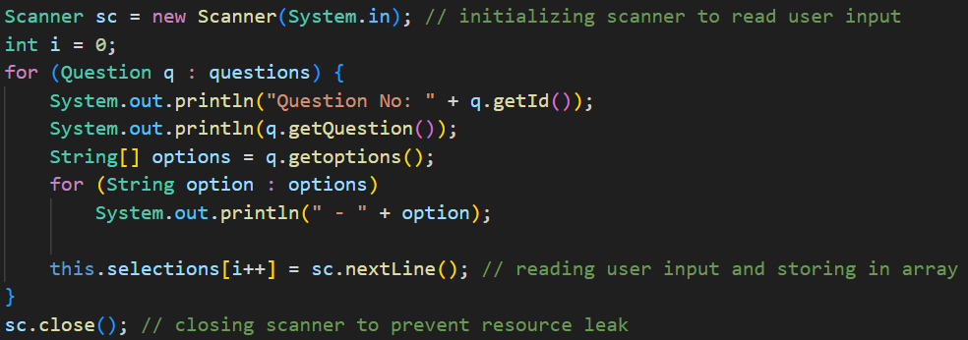
  - Here, I created an object of Scanner, and passed System.in
    - System.in is a static input stream provided by JVM.
    - It represents standard input of your program.
    - Since it is static final, there is only System.in object per JVM process.
    - Once you close the scanner object using sc.close(), you can’t read the input again.
  - Below is an example of wrong usage of Scanner:
    - 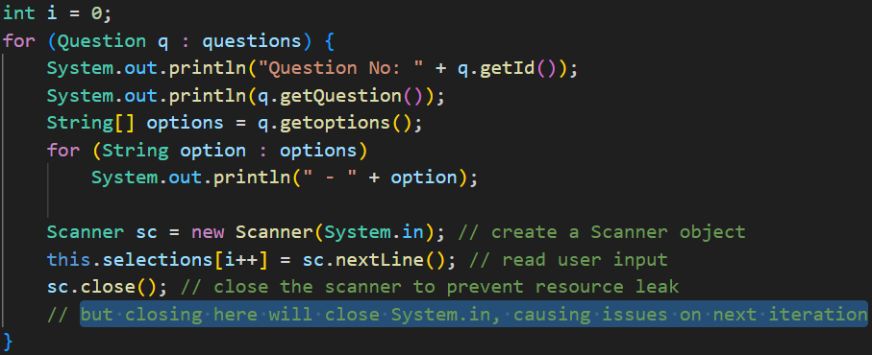
    - Here you’ll get an exception after the first iteration, because System.in is already closed in the previous iteration.
  - sc.close() is optional by the way.
- Abstract Class and Abstract Method
  - In java, empty methods are valid.
    - 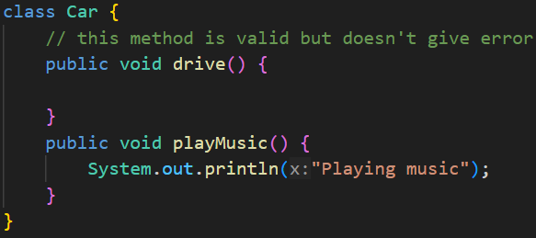
  - These are some conditions in Java OOP:
    - Abstract method inside Abstract class (✅)
    - Abstract method inside Normal class (❌)
    - Normal method inside Abstract class (✅)
    - Normal method inside Normal class (✅ (default only))
  - In short:
    - Abstract method ⇒ class must be abstract
    - Normal methods ⇒ allowed anywhere
  - An abstract class may have:
    - Only abstract methods
    - Only normal methods
    - A mix of abstract + normal methods
    - Even no methods at all
  - 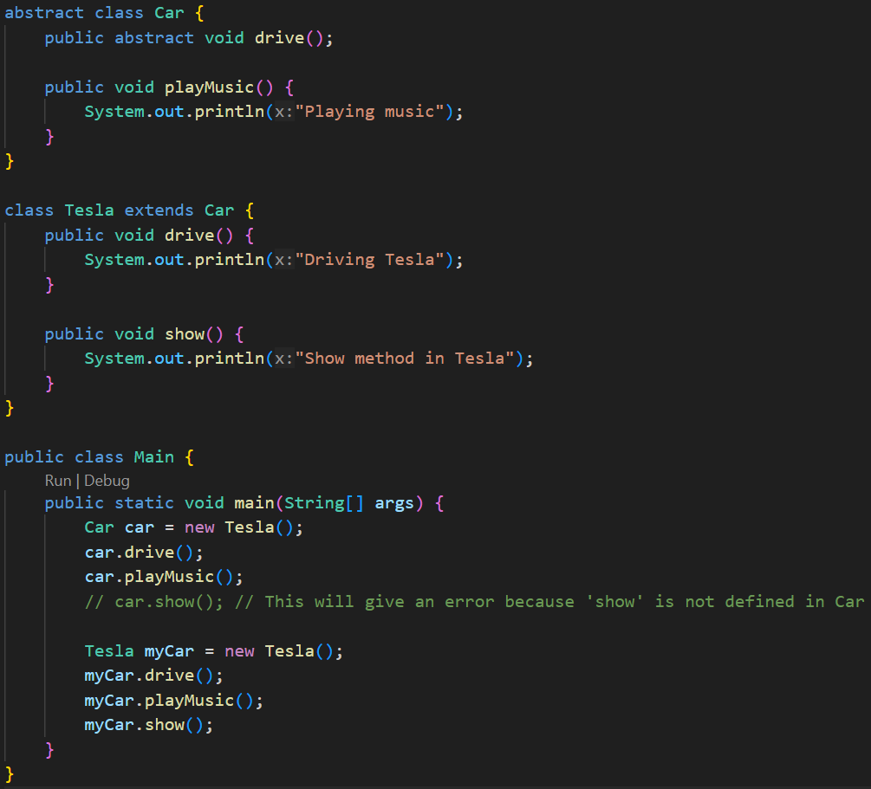
  - If a class is inheriting an abstract class
    - It must implements the abstract methods present inside the abstract class.
    - The normal methods present inside the abstract class need not to be overridden.
  - An abstract class can have constructor.
    - The constructor can be called from the base classes using super()
  - NOTE
    - An abstract class can inherit another abstract class as well.
    - And in this case, the child abstract class need not to implement the abstract methods inside the parent abstract class.
    - 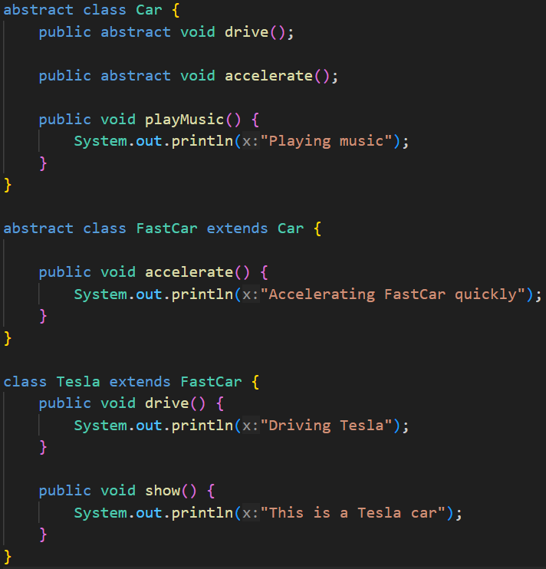

- Inner Class
  - An inner class is a class defined inside another class.
  - It is logically associated with its outer class and has access to its members (even private ones).
  - The inner class’s type will be: OuterClassName.InnerClassName
  - And to instantiate the inner class, you need an instance of the outer class.
  - To instantiate the inner class, you need to call like.
    - obj.new InnerClassName()
  - There are 4 types of Inner Class
    - Non-Static Nested Inner Class
    - Static Nested Inner Class
    - Local Inner Class
    - Anonymous Inner Class
  - Non-Static Nested Inner Class:
    - 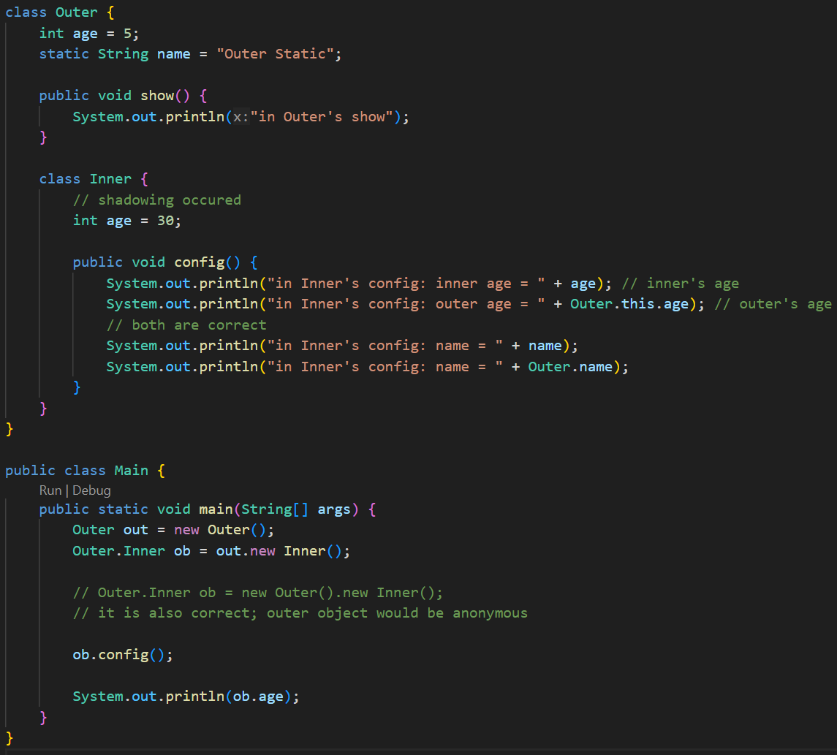
    - Just imagine a non-static method. You can access this only by an object.
    - Just like that, you can access the Non-Static Inner Class using an object of Outer Class only.
    - It can access all the instance and static variables of the outer class (even private variables are accessible).
    - In the above example, the instance variable age got shadowed inside the Inner class. To access the Outer class’s age
      - OuterClassName.this.VariableName
      - Because, this.age would have given InnerClass’s variable age
      - Here we are able to do OuterClassName.this.VariableName because the inner class object is created by the instance (object) of the Outer class. So, Inner class instance can access Outer class instance.
      - But, if you write InnerClassName.this.VariableName from a method present in the Outer class then it’ll not work because the Outer class doesn’t have access to any instance of the Inner class.
    - Why not new ob1.Inner() ?
      - new keyword is used before the class name i.e. new MyClass() like this.
      - But if we write new ob.Inner() then it should be like ob should be one class but its an object.
      - So, we write like ob.new Inner()
      - In case of static inner class, we use new Outer.Inner() because here Outer is a class not an object.
  - Static Nested Inner Class:
    - Declared with the static keyword.
    - It does not need an instance of the outer class.
    - Can access only static members of the outer class directly.
    - Just like static method, we can access the static inner class using the Outer class directly without instantiating it.
    - Here, new Outer.Inner() (not Outer.new Inner() or new Outer().Inner())
    - Inner static class can have both instance and static variables and methods , as we can create instance of the inner class. Those instance variables can be accessed using this keyword inside the inner class.
    - 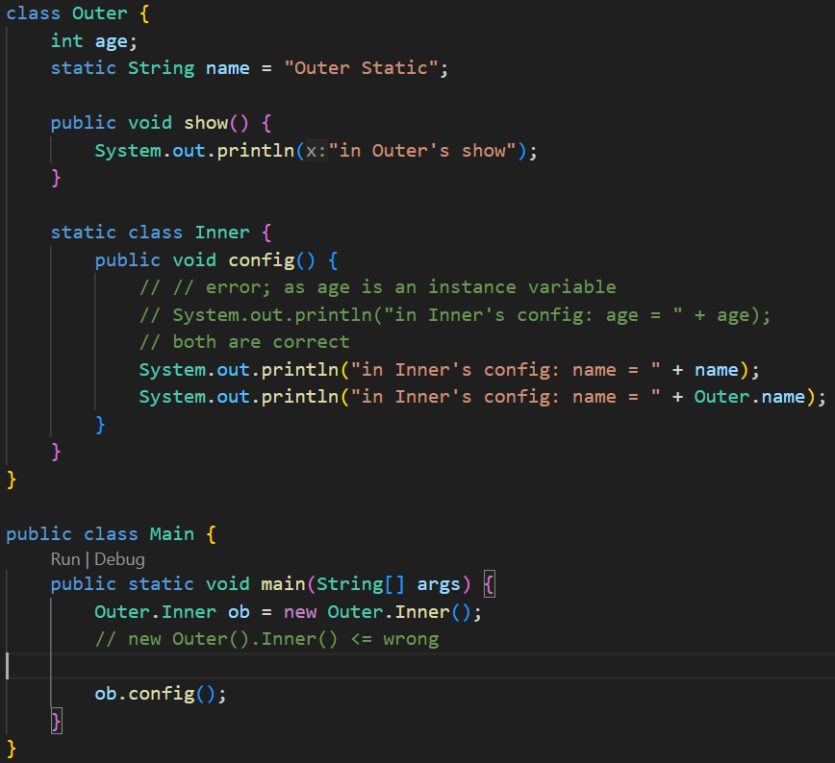
    - 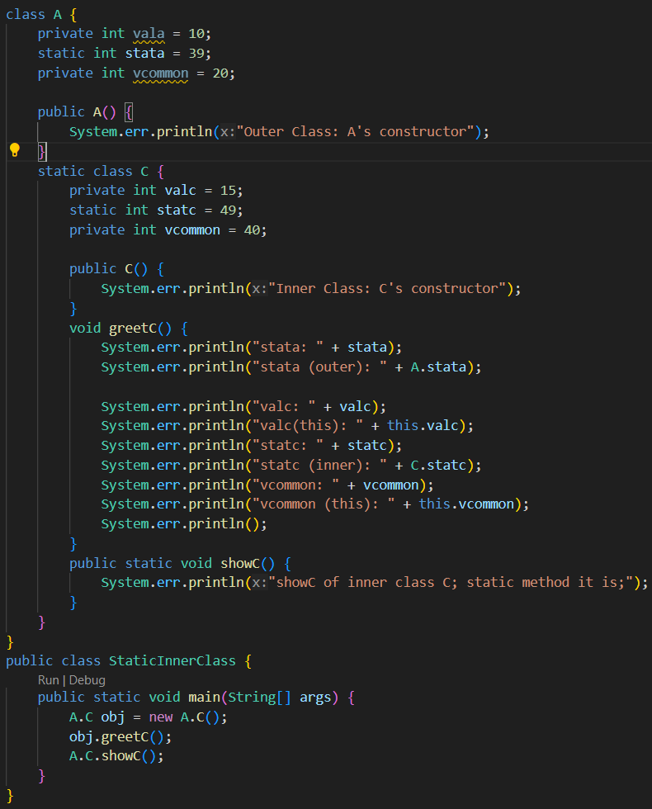

  - Local Inner Class:
    - When the Inner class is defined inside a method of Outer class, then it is Local Inner Class. (It has access to outer class’s instance variables)
    - 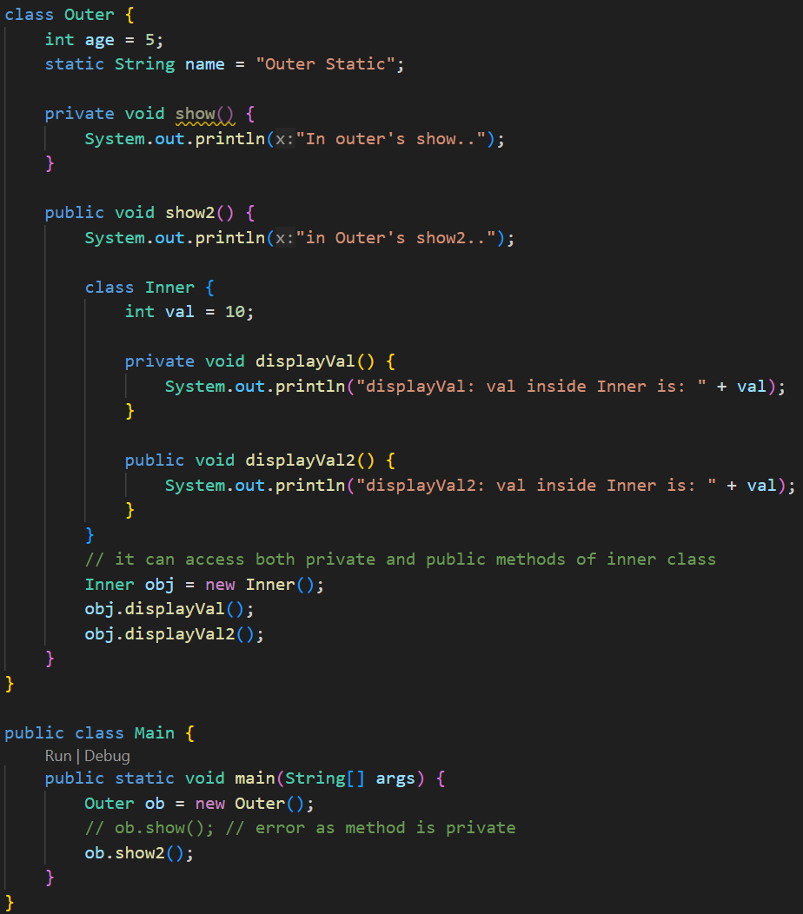
    - It is strange that, the displayVal method is private; but still it was able to get called from outside of it i.e. inside the show() method.
    - As the Inner class comes inside the scope of Outer class, so in this case, all private things of Outer class and Inner class are accessible to each-other.
    - But the private method show() of the class Outer is not accessible outside.
    - Because Inner lives inside the scope of Outer, they can freely access each other’s private members.
    - But Main is outside, so it cannot access Outer.show() or Inner.displayVal().
  - Anonymous Inner Class:
    - 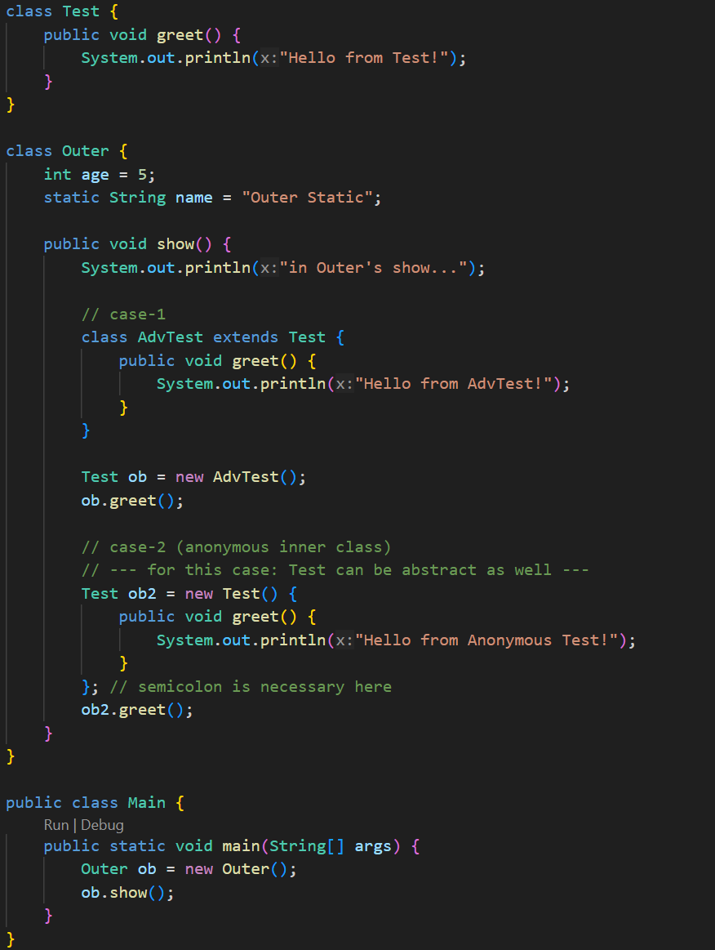
    - 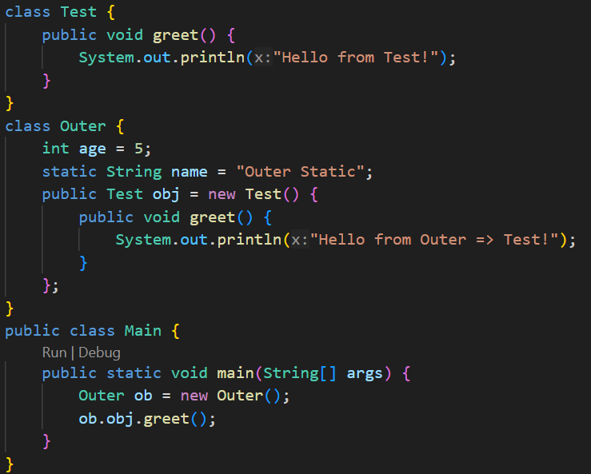
    - Its just like inheriting a Normal/Abstract class and instantiating directly without creating the inherited class.

  - Summary of Inner Classes
    - In any type of inner class creation, both Outer and Inner classes can access each-other’s private members.
    - Non-Static Inner Class:
      - Assumption: Inner class’s name: Inner, Outer class’s name: Outer
      - Just like non-static method, the Non-Static Inner Class can access both instance variables and static variables of the Outer class.
      - If there is any type of shadowing of Outer class’s variable then (let variable name is: val)
        - this.val ⇒ Inner class’s variable val
        - Outer.this.val ⇒ Outer class’s variable val
      - Just like Non-Static Method, we need an instance of the class to access the Non-Static Inner Class.
      - As the Inner class’s instance will be a part of the Outer class’s instance, so to instantiate this:
        - obOuter.new Inner()
    - Static Inner Class:
      - Assumption: Inner class’s name: Inner, Outer class’s name: Outer
      - Just like the Static Methods, the Static Inner Class can only access the static members of the Outer class.
      - If there is any shadowing: (let the variale name is val)
        - val ⇒Inner class’s static variable
        - Outer.val ⇒ Outer class’s static variable
    - Local Inner Class:
      - The Inner class is defined inside a method of the Outer Class.
      - The scope to access this Inner class is only the scope of that Method.
    - Anonymous Inner Class:
      - Its just like extending a class (either Normal or Abstract) and creating an object out of that; without creating the Class.
      - The syntax is:
        - ClassName obj = new ClassName() { /* override method if want */ }

- Interface
  - Interface can’t have constructor.
  - By default the variables inside interfaces are: public static final.
    - So, static methods can also access those variables.
    - Static methods can be called as: InterfaceName.staticMethodName(…args)
    - So, you need to initialize while declaring it.
    - 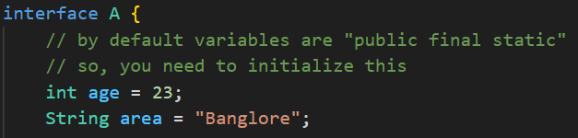
    - You cannot override the variables that were declared and initialized in interface.
      - 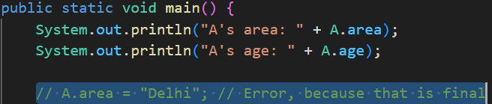
  - By default all the methods are public abstract; you don’t need to explicitly write that.
    - 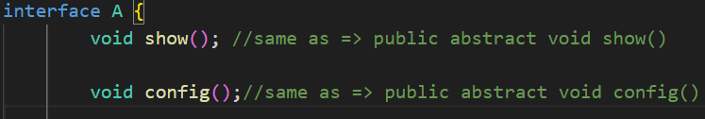
  - implements is the keyword that is used to implement a interface to a class.
  - Unlike classes, multiple implementations are allowed in case of interface.
    - 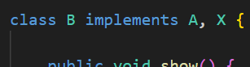 (multiple implementation)
  - Interfaces can inherit another interface.
    - In this case, multiple inheritance is allowed.
    - 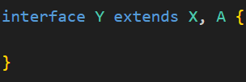
    - But the class which implements Y, has to override all the methods mentioned in interfaces X and A.

  - NOTE
    - Interfaces cannot have constructors (because they can’t be instantiated).
    - But you can create a reference of an interface type pointing to a class object.
    - Interfaces are used to achieve abstraction and multiple inheritance in Java.
  - 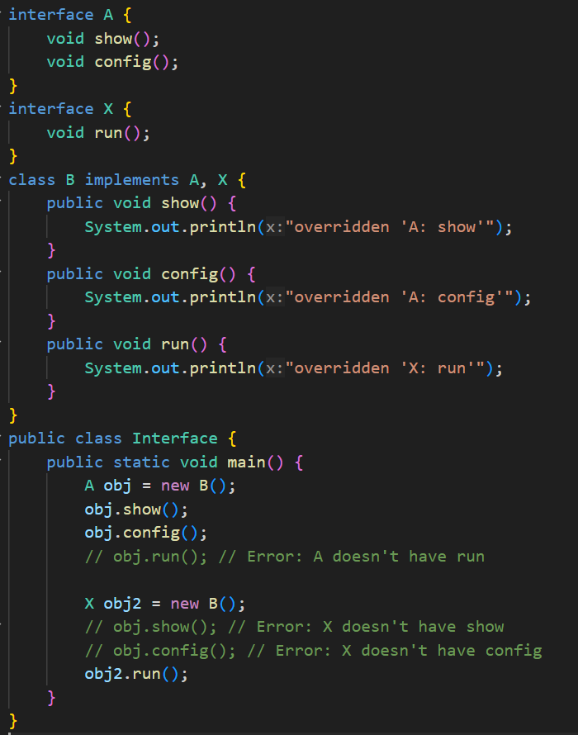
    - In case of implementing 2 interfaces, creating object of one interface type and calling the method mentioned in the other interface will not be possible.
    - We had seen this during Upcasting and Downcasting.

- Need of Interface
  - You can see the below example code.
  - Here if we didn’t have implemented an interface, only Laptop or Desktop type of objects would have been acceptable inside the codeApplication method of Developer class.
  - Now we can think, instead of interface, abstract class can also be used;
  - But, just to write a abstract method, why to create an abstract class.
  - Interface is here simple and doing all the required things.
  - 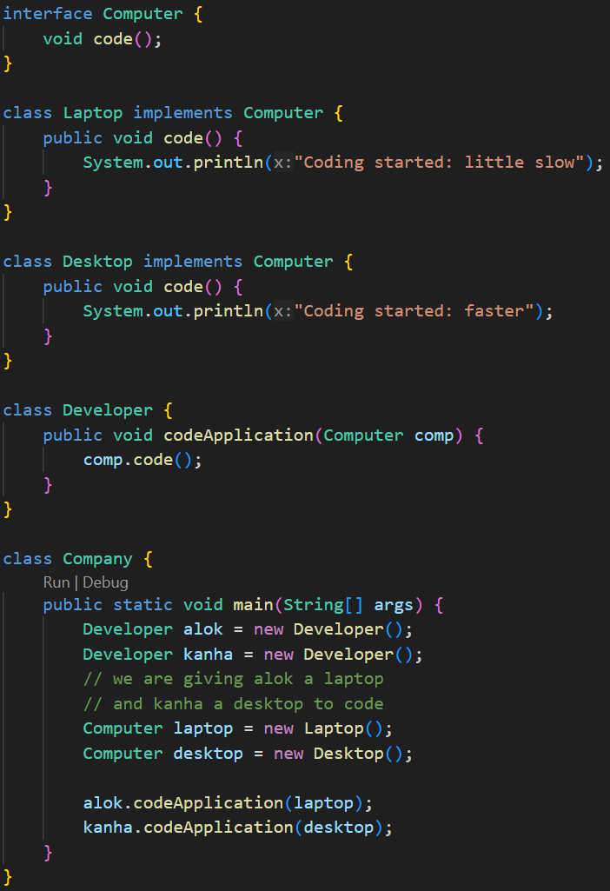

- Enum
  - enum is a special type of class in Java (its not same as Class; but similar).
  - It’s a final class which cannot be inherited by any other class.
  - 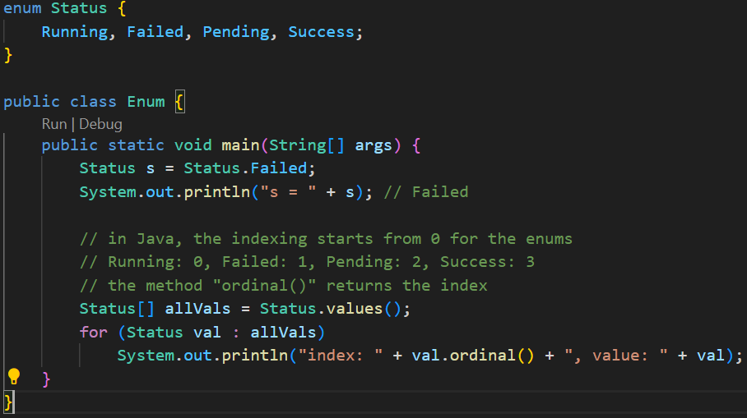
  - switch case statement also supports enum, so it can be used to check the status.
  - Consider the following example: (more than one constructor can be created)
    - 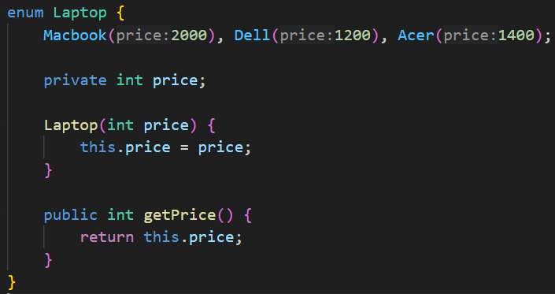
    - 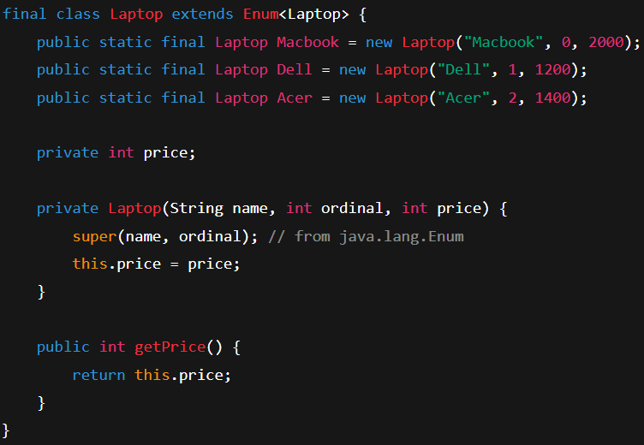
      - Behind the scene.
    - 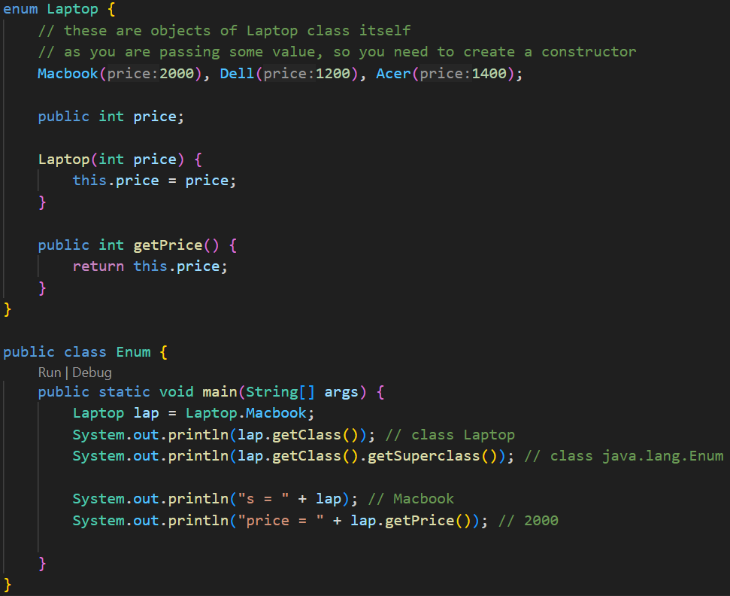
  - enum only supports private constructor.
  - 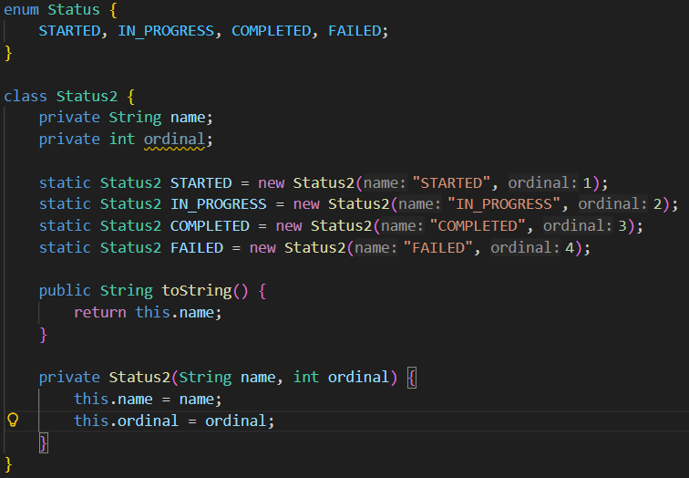
    - Manual creation of Enum (not proper; just to understand)

- Annotations
  - Provides information to the compiler, tools, or runtime.
  - Think of it as a special marker/label you attach to classes, methods, variables, etc.
  - For example @Override
    - It tells the compiler: “this method is supposed to override a method from its super-class.”
    - If it doesn’t, the compiler will show an error.
  - 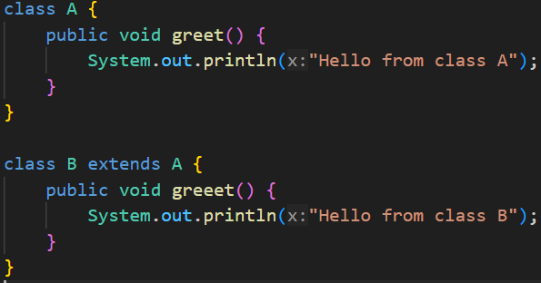
    - Here you can see, I have made a spelling error in Class B.
    - Instead of greet I have written greeet
  - 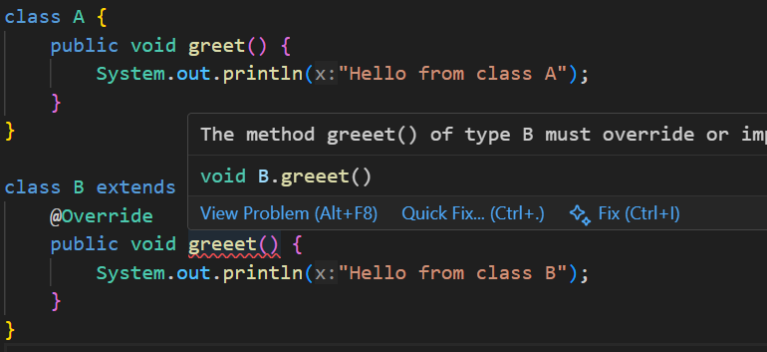
    - Now I used the annotation @Override , so now the compiler is showing me the error that this method doesn’t exists in the superclass.

- Types of Interface
  - Normal Interface
    - Interface having 2 or more methods
  - Functional Interface / SAM (Single Abstract Method)
    - Interface having only 1 method.
  - Marker Interface
    - Interface having no method.
    - used for tagging or marking classes (e.g., Serializable).
  - Functional Interface:
    - 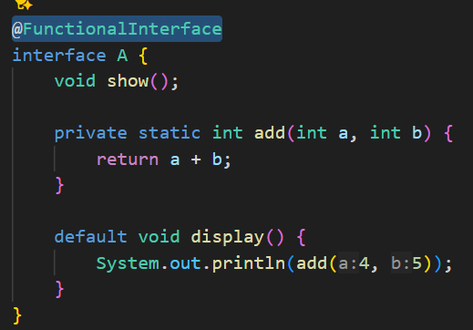
      - Abstract method should be only 1.
      - Remaining static or default methods can be there.
      - Annotation: @FunctionalInterface
    - 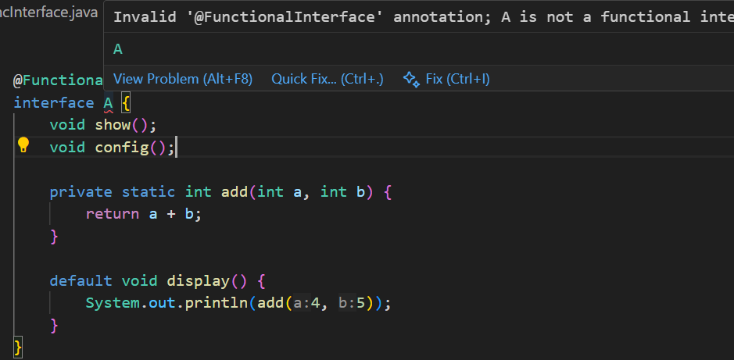
      - I added one more Abstract method, so it is showing me error.

- Lambda Expression
  - 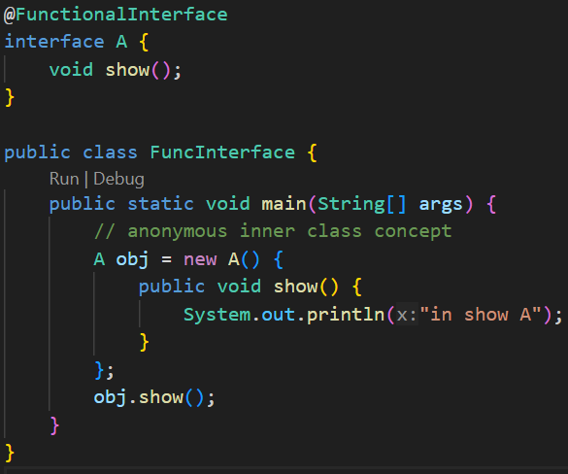
    - This code is proper and it’ll work fine.
  - 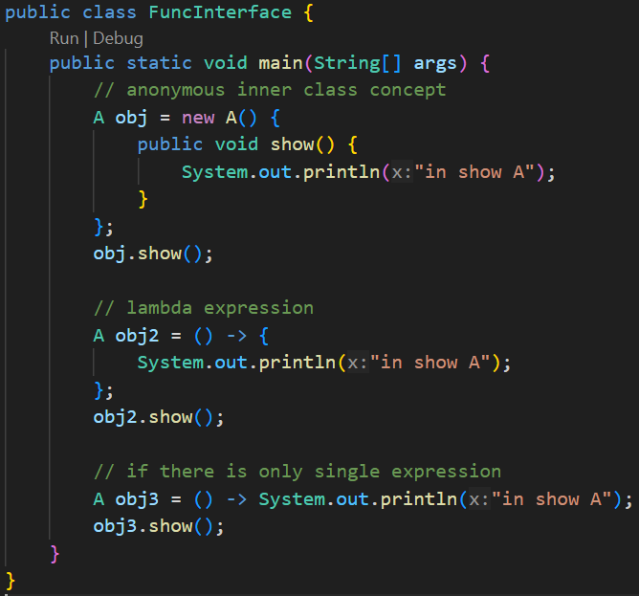
  - 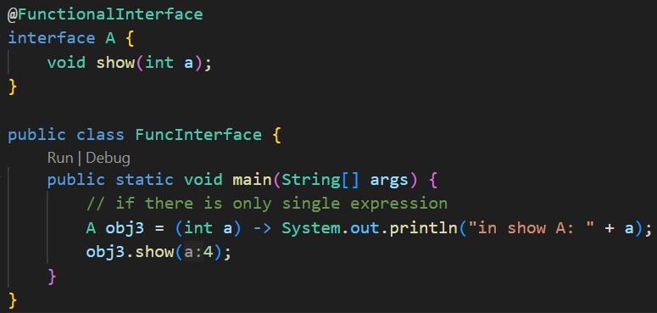
    - You can also pass the arguments.
  - 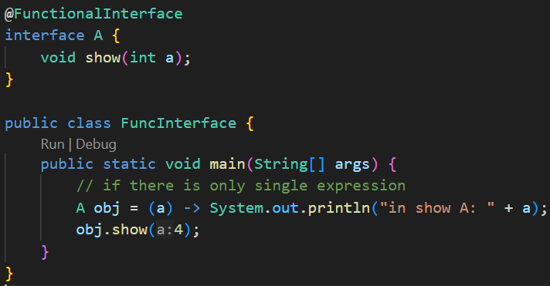
    - You don’t even need to provide the data type; it’ll take from the interface directly.
  - 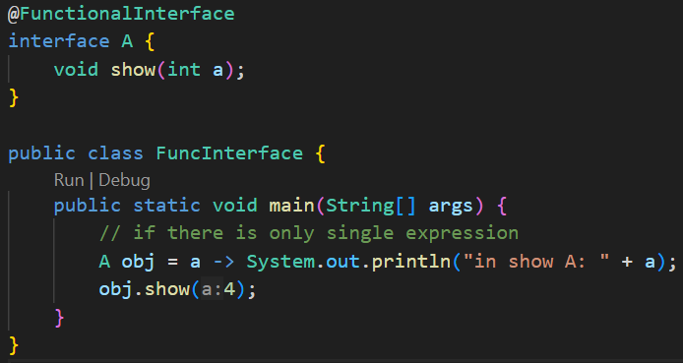
    - If you have only one argument, don’t need to give the parenthesis as well.
  - 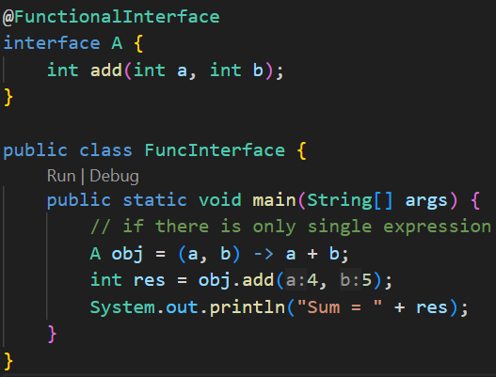
    - You can directly return the values like this.
  - Lambda Expression only works with the Functional Interface.
  - Because if there are more than one method, which will be implemented.
- Exceptions
  - Compile time error and Logical Errors can be fixed;
  - But Run Time error should be handled. So that the application won’t stop in between.
  - Exception Handling is nothing but handling these Run Time error.
  - 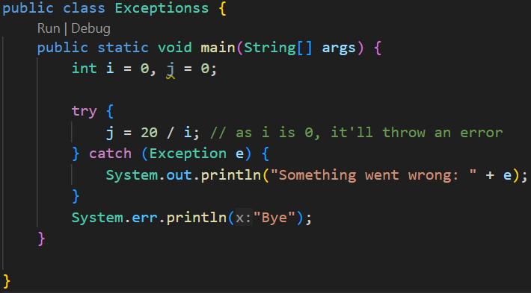
    - Handling Exceptions using try catch block.
    - 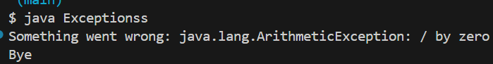
  - 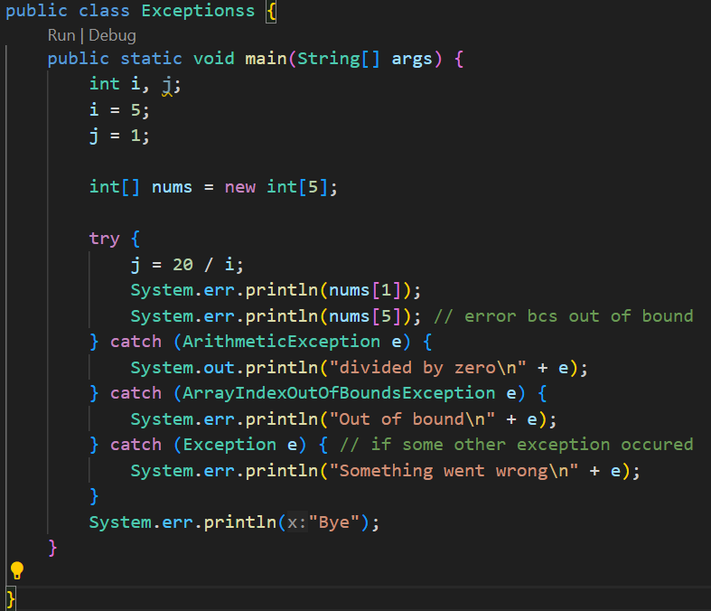
    - Using multiple catch blocks to catch different types of Exceptions.
  - 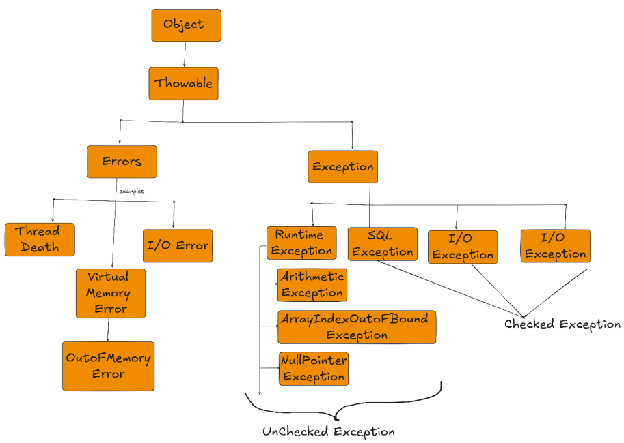
    - This is the hierarchy of Exception classes.
    - Checked means the exceptions that are checked during compile-time. i.e. IOException, ClassNotFoundException, SQLException
    - Unchecked means the exceptions that are occur during the run-time i.e. NullPointerException, ArithmeticException, ArrayIndexOutOfBoundException ..etc etc
  - 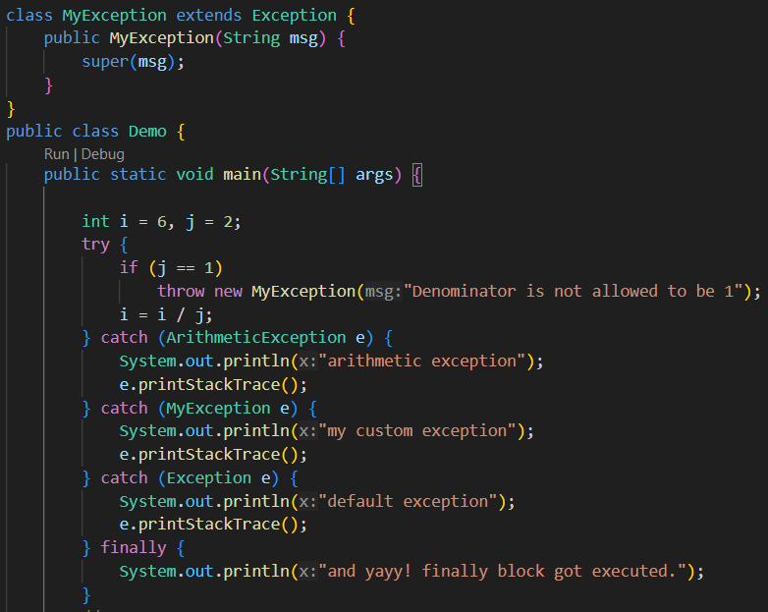
- throw Keyword
  - 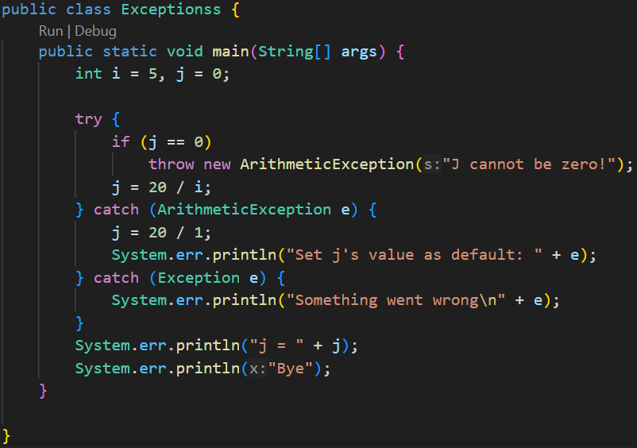
    - We can throw any kind of exception we want by giving some customized error message.
  - 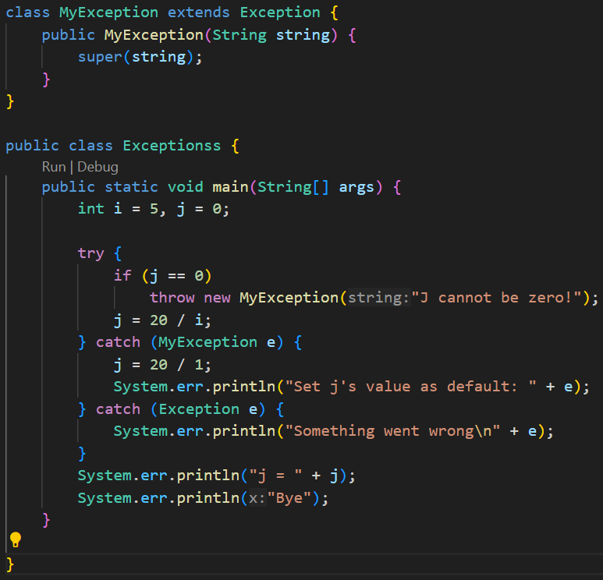
    - It is a custom exception.
    - You need to inherit the Exception class or can also inherit RuntimeException class; and pass the string to the super class’s constructor because those Exception classes handles this message.
    - 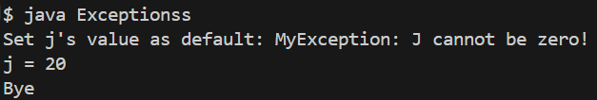
- throws keyword (written in method level, not class level)
  - throws required only for checked exception. For unchecked exception by default it populate back.
  - Let suppose, in a method A , you are calling 2 methods B and C.
  - B and C both are having a critical expression that might throw the same Exception.
  - So, instead of handling those inside B and C both, we can handle those inside A directly.
  - For this, throws keyword will be used in B and C.
  - It is used to forward the Exception to the method where the current method is called.
  - Lets A is being called in some another method X, if you mention the keyword throws in the method A as well, then the Exception occurred from B and C will go to A then it’ll go to X.
  - 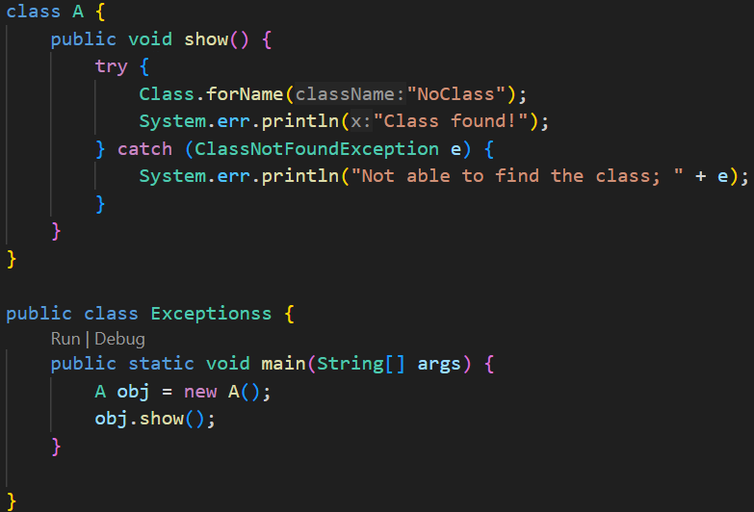
    - Simple code only; exception will be thrown inside the show() method and will be handled there only.
  - 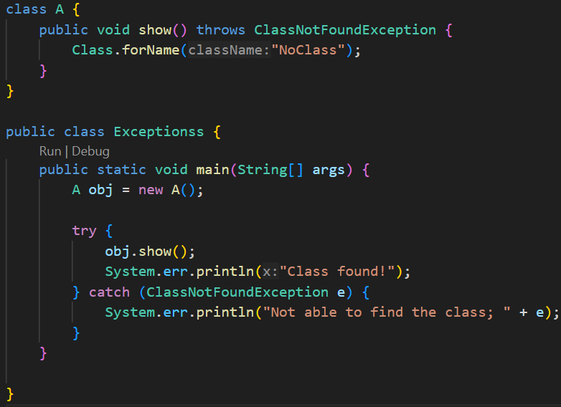
    - So, like this you can use throws to forward the Exception to calling method.
  - 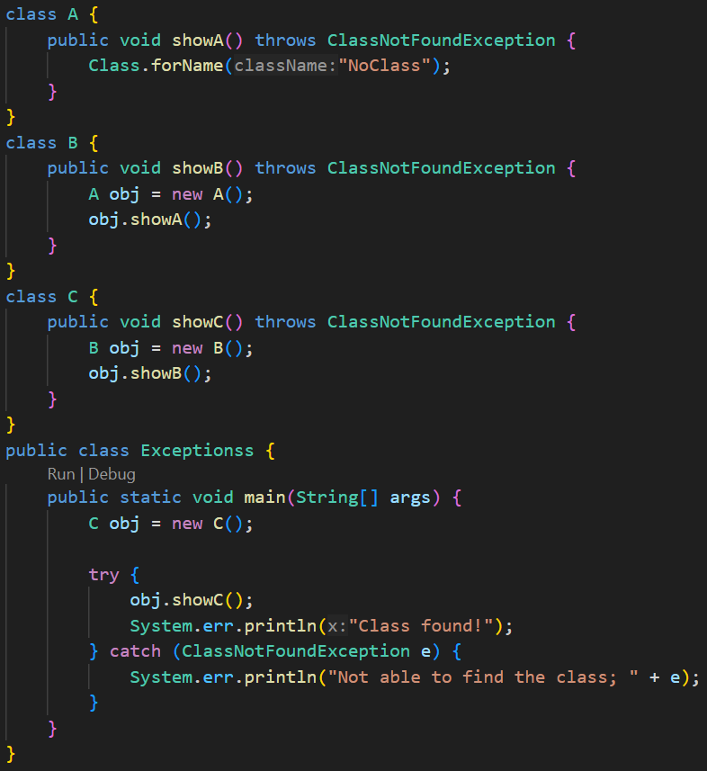
    - Here the exception flows from A to Exceptionss class:
      - A’s showA ⇒ B’s showB ⇒ C’s showC ⇒ Exceptionss’s main
  - In the following case it’ll give error.
    - 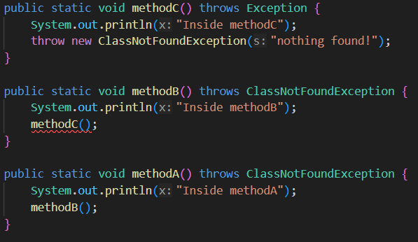
    - Here method is throwing Exception (superclass) but methodB only handling ClassNotFoundException which is one child class of Exception.

- User Input
  - When we write System.out.println(“…”) it prints something in the CLI.
  - Here, System is a class where there is a static variable which is out.
    - 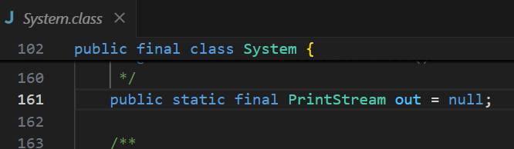
  - And, this out variable is of type PrintStream.
    - Inside the class PrintStream, there is a method which is println,
    - This is how, System.out.println works.
  - Just like that out variable, another variable is there inside the System class which is in
    - 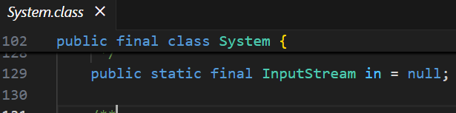
    - It is of type InputStream
  - Inside the class InputStream, so many methods are there like read, readAllBytes etc etc.
  - 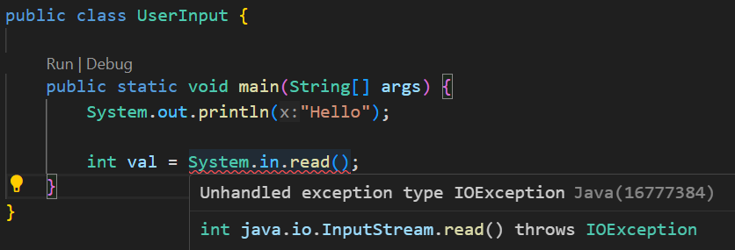
    - As we can see, it is saying that read method might throw IOException (it is a checked exception; so it’ll give error during compilation)
  - Just to handle this temporarily, I am appending the throws keyword in the main method (It is not at all preferable; because if the main method throws the exception, it’ll go to JVM directly and the application will stop).
    - 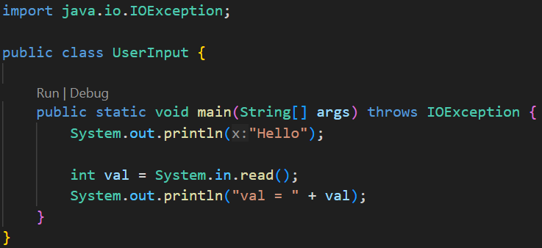
    - Now the compilation error gone.
    - 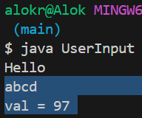
      - It’ll just return the ASCII value of the first character (here ‘a’)
  - 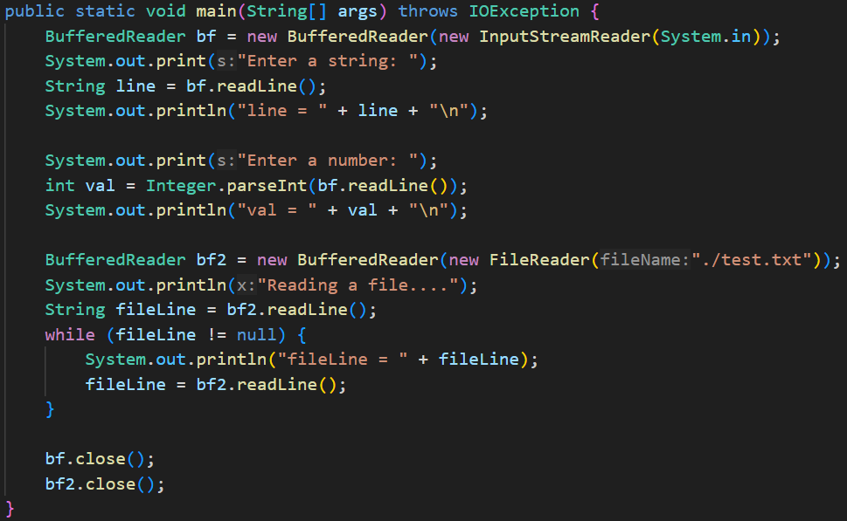
    - 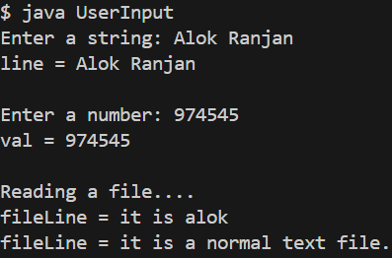 (Output)
    - It is how we can take input from user using BufferedReader.
    - BufferedReader constructor takes an Reader type argument.
      - First case, I took InputStreamReader, it’ll be used to take user’s input from terminal.
      - Second case, I took FileReader, it’ll be used to read a file.
    - Here bf and bf2 (BufferedReader instance) are resources. So whenever you create these, you have to close it as well.
      - It’ll not give any error, but it is a good idea to close the resources.
  - 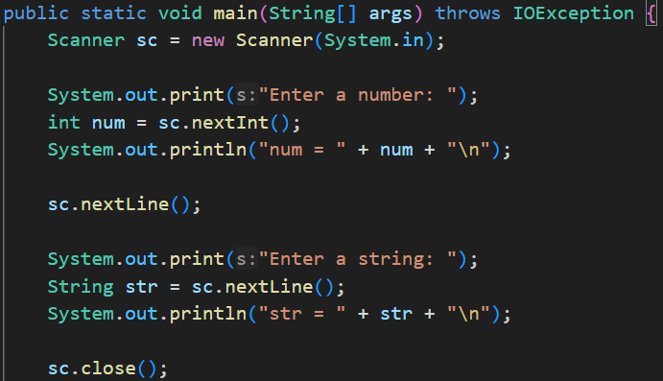
    - 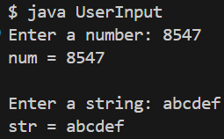 (Output)
    - Here you must be thinking why we have written sc.nextLine() in between.
      - When you give input and hit Enter, the next sc.nextLine() will take that as its input.
      - So, you can’t take the input for the string here because it’ll take that \n (Enter) as its input.
      - 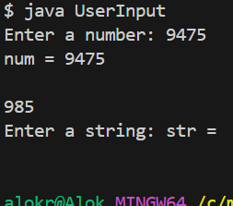 (it would have occurred without that middle sc.nextLine())
- Try with Resources
  - There is a keyword finally; this block executes even if the Exception occurred (catch) or not (try).
  - Even you can just run try and finally without catch.
  - The finally block is mostly used to close the resources.
  - Without this finally block, we would have to close the resources on both try and catch blocks.
  - 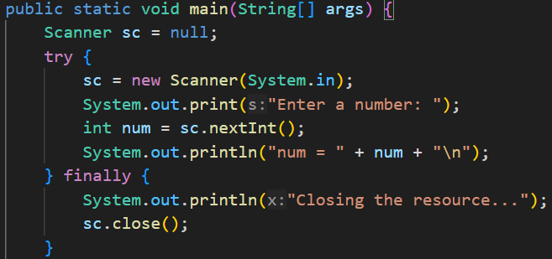
    - This is how we can use the finally block to close the resources.
  - 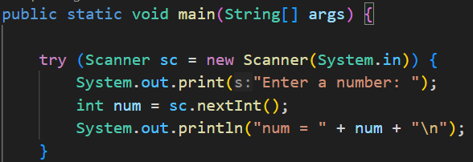
    - It is a short syntax.
    - Here, after the try block is completed, the resource will be closed automatically.
    - You can see, the Scanner class’s ancestor is the AutoClosable interface, so it’ll be automatically closed.

- Threads
  - There is a class Thread in java, which has a method called start().
    - This start() method call a method whose name is run().
    - So, if you want to run a method in a thread, then you need to give run as the method name.
    - Below is the example of threads:
      - 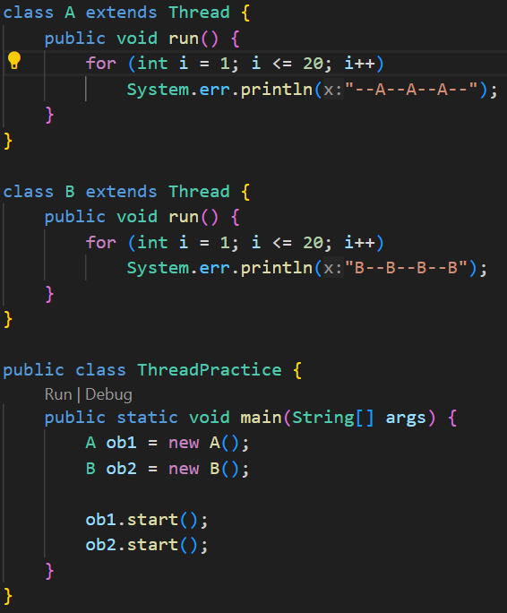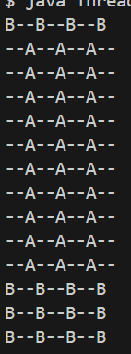
        - Output is not continuous like --A--, --B--, --A--, --B-- like this
    - If your CPU has n cores, then n threads can be run at a same time.
      - In modern systems, 1 core may be able to run 2 or more threads at a same time.
    - 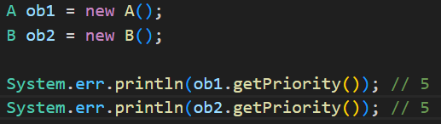
      - The priority range is from 0 to 10.
        - 0 is least priority and 10 is highest priority.
      - To set the priority, we can use setPriority method.
    - 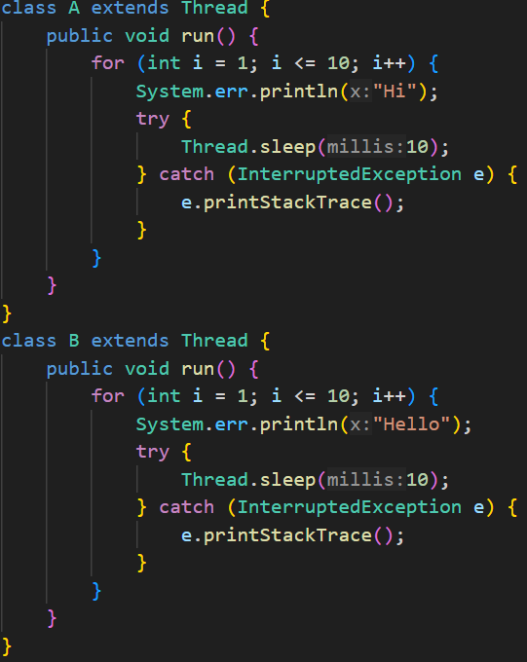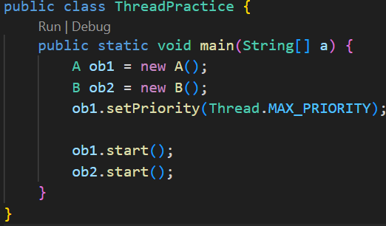
      - (System.out, not System.err (minor mistake :))
      - Here, I gave some sleep to make the output alternate Hi, Hello, Hi, Hello.. like this.
      - 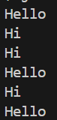 (you can just optimize it; how it’ll work can’t control)
      - In above case, might be both the run came to the scheduler to get executed after their respective sleep of 10 milliseconds (mentioned in code), then scheduler might have given someone.
- Runnable vs Thread
  - It is not a good idea to inherit the Thread class to make a thread.
  - Because, if the class has to inherit some other class, then it can’t be done in this case.
  - 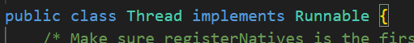
    - The Thread class implements an functional interface Runnable, and the run method is present inside the Runnable interface only.
      - 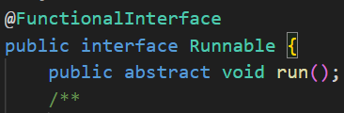
  - 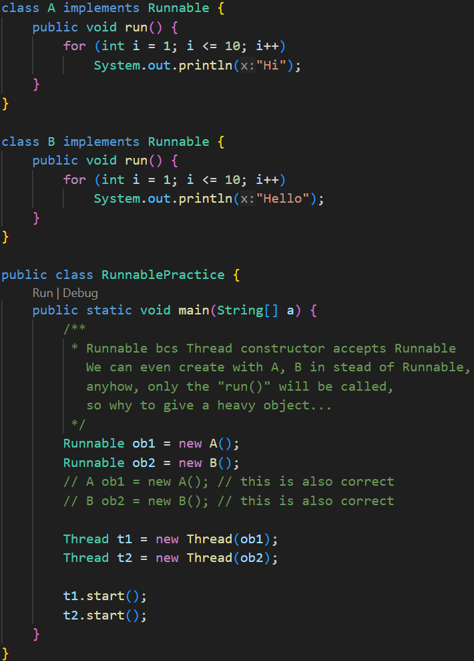
    - It is how Runnable and Thread work.
  - 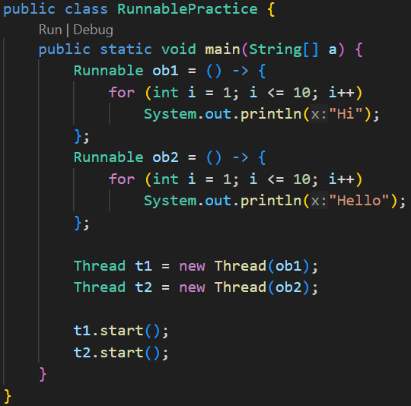(using lambda expression)
- Some subtle links between Thread and Runnable
  - 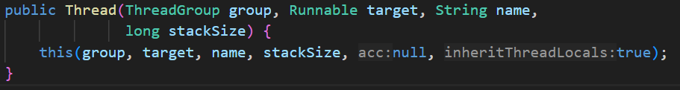
    - This is the main constructor of the Thread class.
    - target is of Runnable type.
  - When we extend the Thread class by any custom class, by default the default constructor of the Thread class (non-parameterized constructor) gets called.
    - It is the default constructor of Thread class.
    - Here we can see, the target is null.
  - So, when we extends Thread class from our class, the target is null.
  - Also there is a run() method inside the Thread class which overrides the run() method of the interface Runnable.
    - 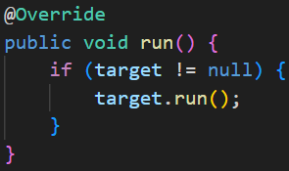
    - In case of extending Thread class, we override this run() method, so that our run() method (present in our class) will get executed.
  - One more constructor inside Thread is there which accepts target .
    - So, if we are not extending the class, we need to pass a Runnable type object inside the Thread constructor while initializing.
    - Our custom class can implement the Runnable interface and that object can be passed inside the Thread class’s constructor.
  - In simple words:
    - start() method will trigger the run() method of Thread class.
    - In case of inheriting, the run() method of Thread class is overridden by our own class. So, our run() method gets executed.
      - Runnable’s run() --- Thread’s run() --- CustomClass’s run()
      - This is the overriding hierarchy.
    - In case of implementing runnable, the run() method of Thread class doesn’t get overridden, so the start() method will call run() method of Thread class as it is. As this run() method is running target.run(), i.e. its running the run() method of the Runnable, (and our own class has overridden the run() method of runnable), so our run() method gets executed.
      - Runnable’s run() --- CustomClass’s run()
        - These are same as Thread’s target.run

- Race Condition
  - When 2 threads are running, they should not modify one variable at the same time.
  - Like imagine transacting to 2 different persons from the same bank account at the same time, it’ll cause issues.
  - When you start the threads in side a method, the method doesn’t stop there and execute the remaining code after starting the thread.
    - If you want to execute the statements after the threads are complete, then use join() method.
  - 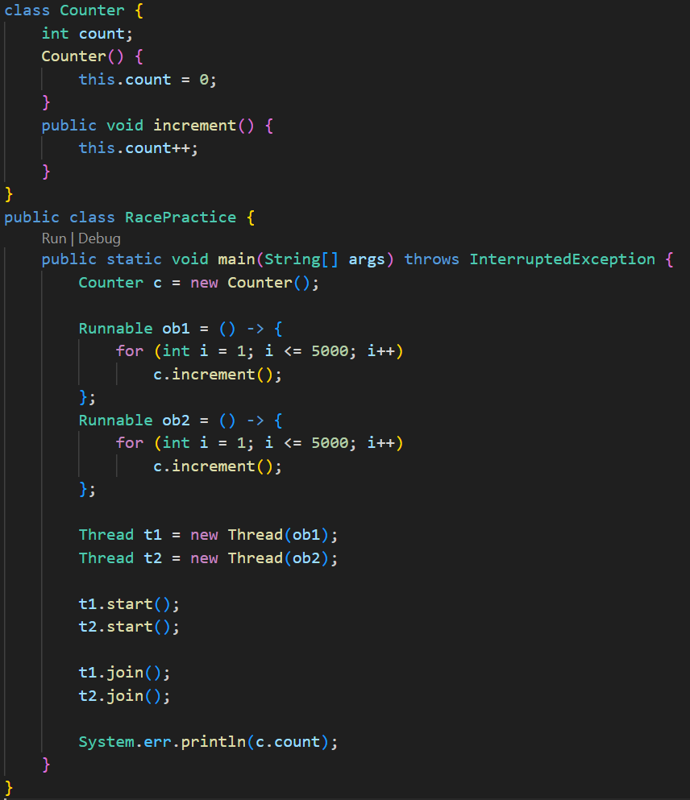
    - This code should give the output 10000, but the output will not be consistent.
    - 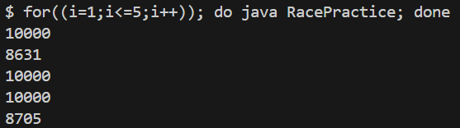
    - I ran for 5 times, the results are inconsistent.
  - It is happening because, at sometimes, both the threads are executing the increment() method at same time;
    - Lets value of count was 100 at a time, both executed increment() method at that time.
    - So, now, instead of 102, the value of count became 101.
    - This is the cause of the inconsistent result.
  - There is a keyword called synchronized, it doesn’t allow the method to be called 2 times at once.
    - 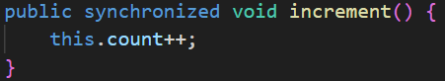
    - 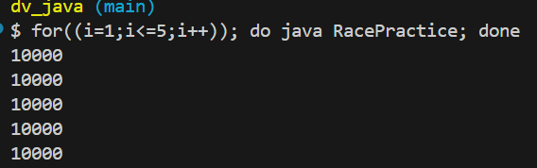
    - Now, the result is consistent.

- Thread States
  - 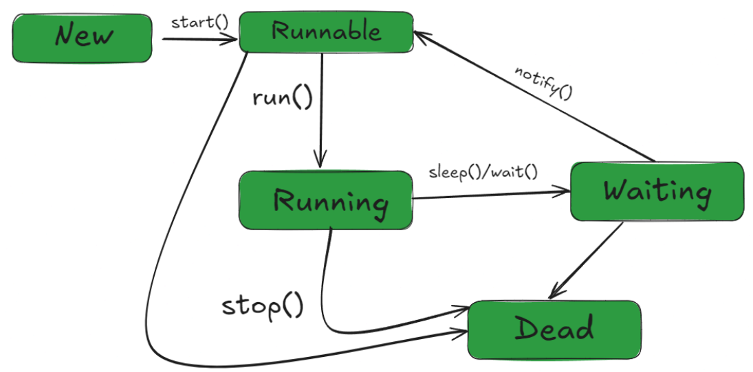

- Collection API
  - Collection API : concept
  - Collection : interface
  - Collections : class
  - 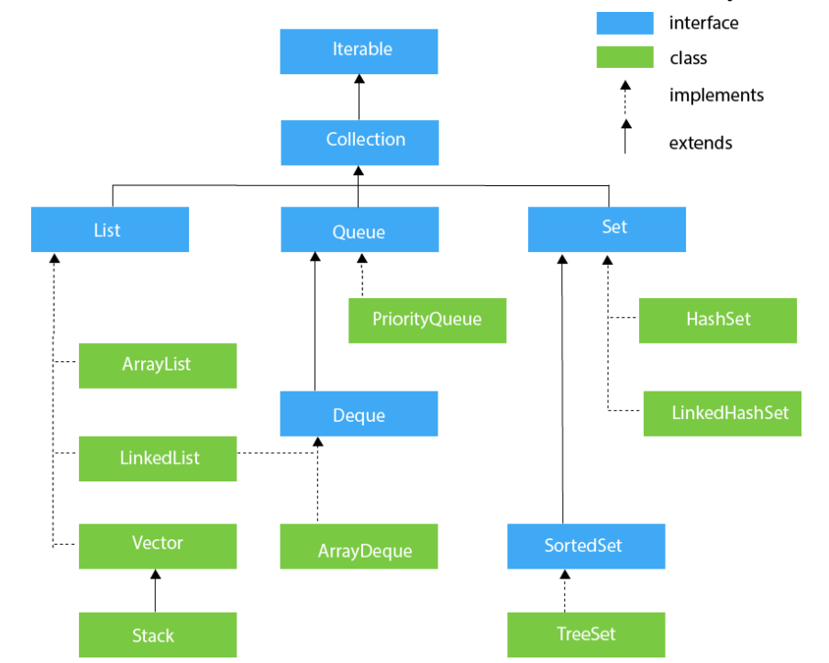

- ArrayList
  - 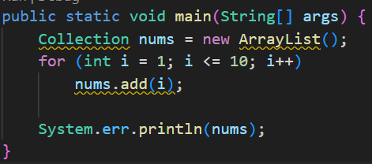
    - Here, you can directly print the object.
    - 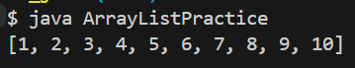
    - Here you can’t access the values like nums[2]
    - You can use nums.get(2) to get the value at index-2.
    - In the above code, we have taken nums as Collection type. In that Collection interface, there is no method called get().
    - The type of nums should be List or ArrayList or something like that.
  - 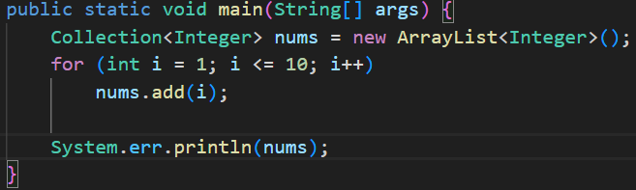
    - The warning that was coming before, was due to not specifying the type.
    - Note: here you can use Wrapper type (Integer, Double etc.) not primitive type (int, double etc).
  - 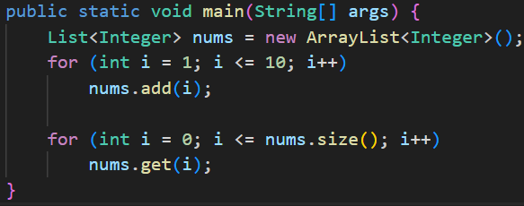
    - Now we used List in place of Collection, so we can use the get() method now.

- Set
  - Whenever you add some values in a set, sometimes it looks like sorted; but it is concidence.
    - Internally, it stores elements in a hash table based on the element’s hash code.
    - The iteration order you see depends on how the hash table buckets are organized.
  - 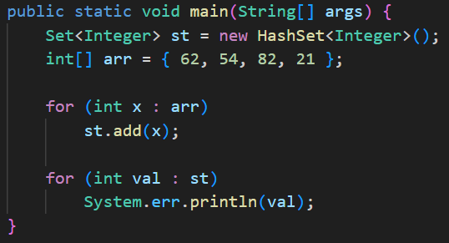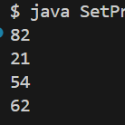
    - Set is interface; HashSet is class
  - If you want a sorted set, then go for TreeSet instead of HashSet
    - 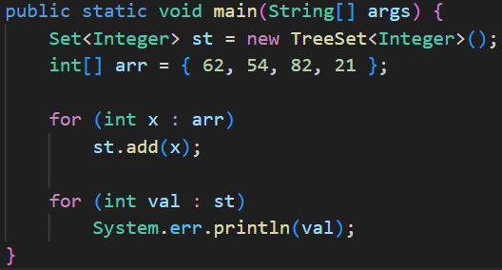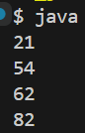

- Map
  - 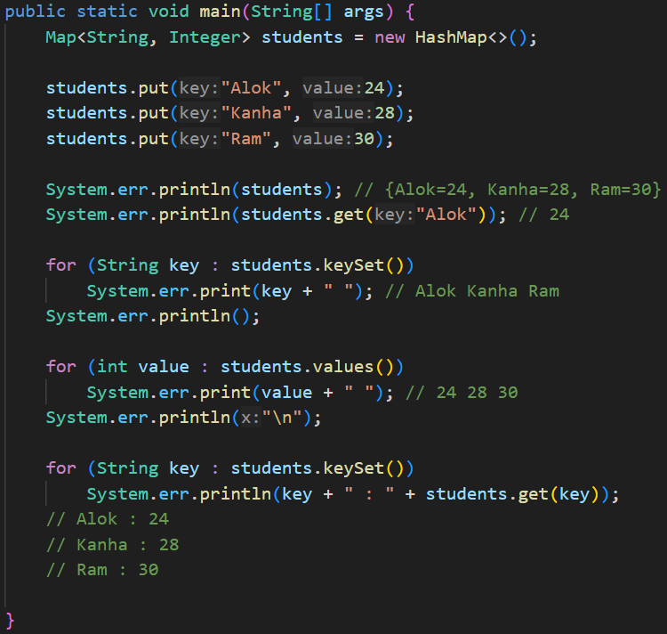
    - The HashMap is not synchronized.
    - To use synchronized version, use HashTable.

- Comparator vs Comparable
  - The Collections class contains static methods that operate or returns collections.
  - 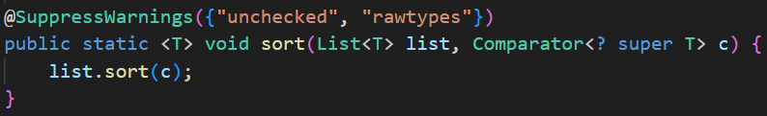
    - This is the sort() method.
    - Here Comparator is there; Comparator is nothing but a Functional Interface containing a compare() method.
    - 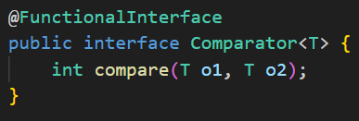
  - In the below code snippet, the list nums will be sorted according to its values.
    - 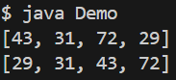
    - 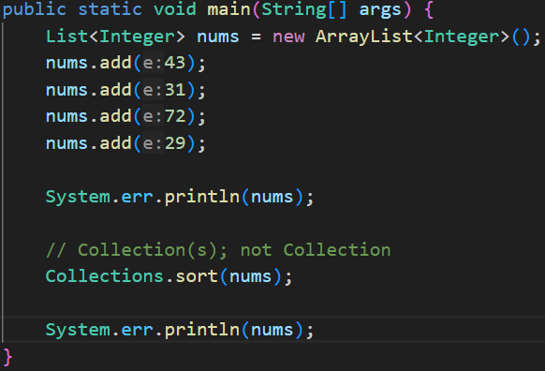

  - I want to sort the values by their right most digit:
    - 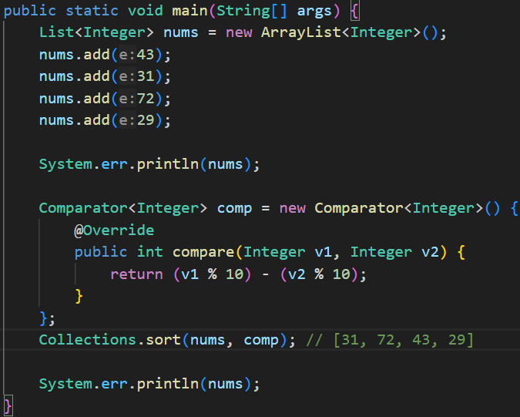
    - 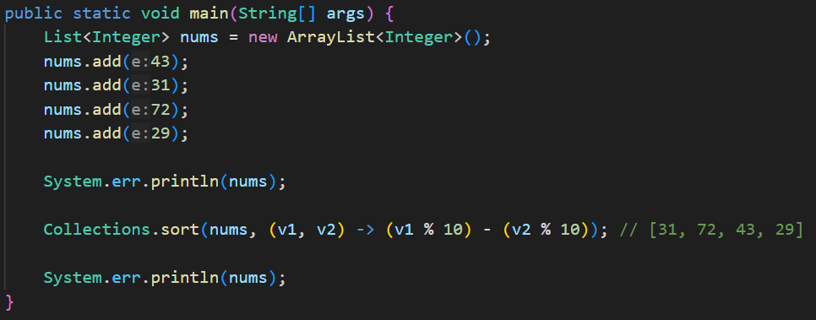
      - Using lambda expression.
  - 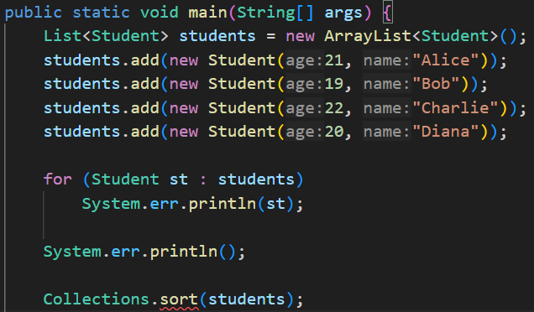
    - Here, in case of a list of objects, sort() method is not working without passing the comparator.
    - 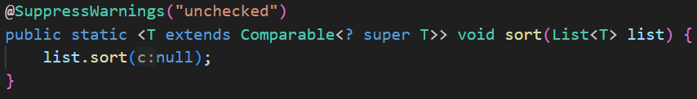
      - It is the sort() method, it requires that the Type (i.e. Integer, Double etc etc) should be of Comparable.
      - 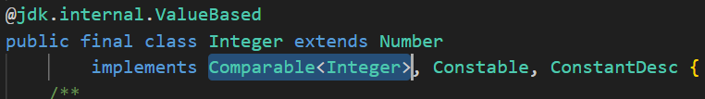
        - You can see, Integer is implementing Comparable; so it can be used in the sort() method without passing the comparator.
    - 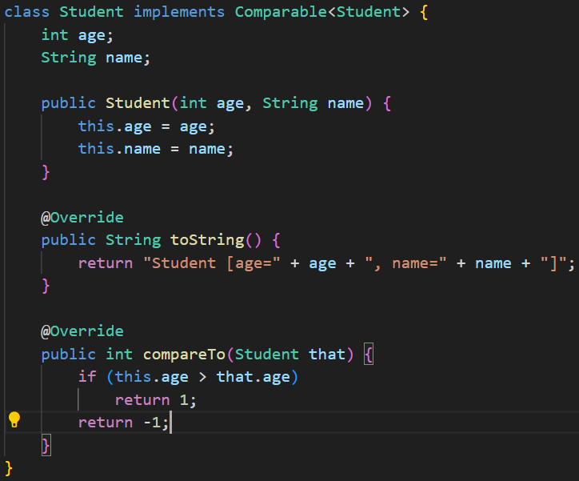
      - Now, we implemented the Comparable interface in the Student class, and overridden the compareTo method inside it.
      - Now, when we sort without using comparator, it’ll not give any error.

- forEach method
  - 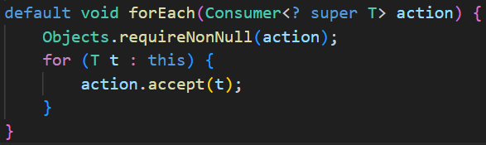
    - It accepts a Consumer typed object.
    - Consumer is a functional interface.
    - <? super T> means, type should be T or any of its super class.
  - 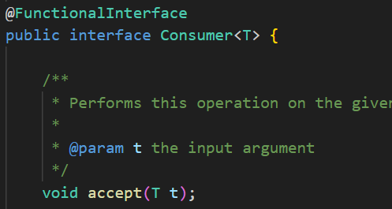
    - This the abstract method that is to be overridden.
  - 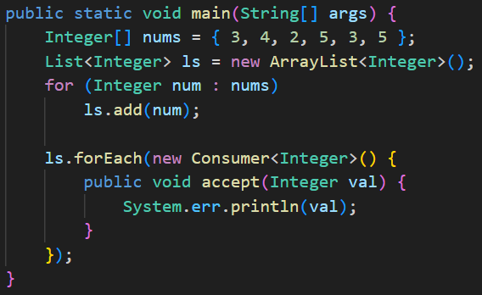
    - It can also be written like this.

- Stream API
  - You’ll get a method in the List objects called stream().
  - It’ll create a Stream object containing all the methods that List has.
  - Even if you change something inside that Stream object, nothing will affect the original list.
  - But the condition is: the Stream object can be used once. If you use it more than once, it’ll give Run time exception.
  - 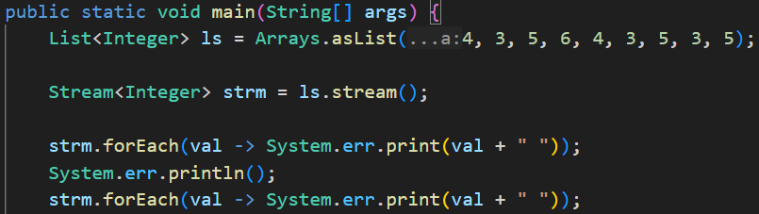
    - 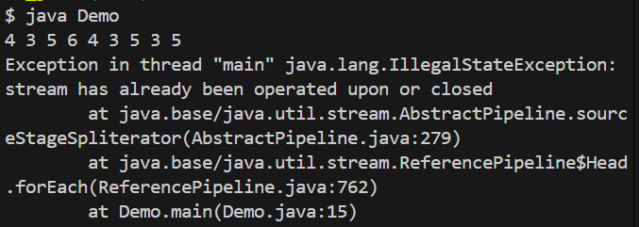
    - Run-Time exception. Only once the Stream object can be used.
  - Using of stream provides so many methods like map, filter, flatMap, sorted, ..etc. These are part of Stream API, not part of the List or something like that.
  - 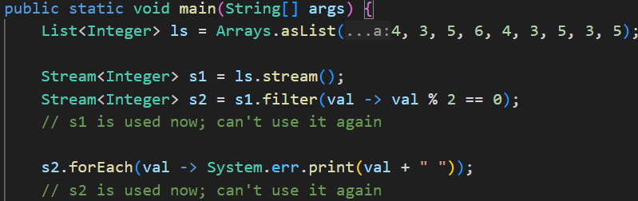
  - 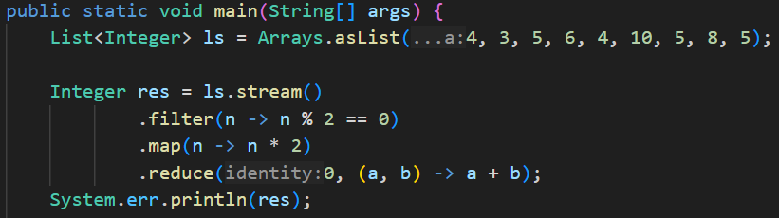
    - As the return types of these stream api’s methods are Stream only, so we can chain these kind of methods.
- parallelStream in Java
  - 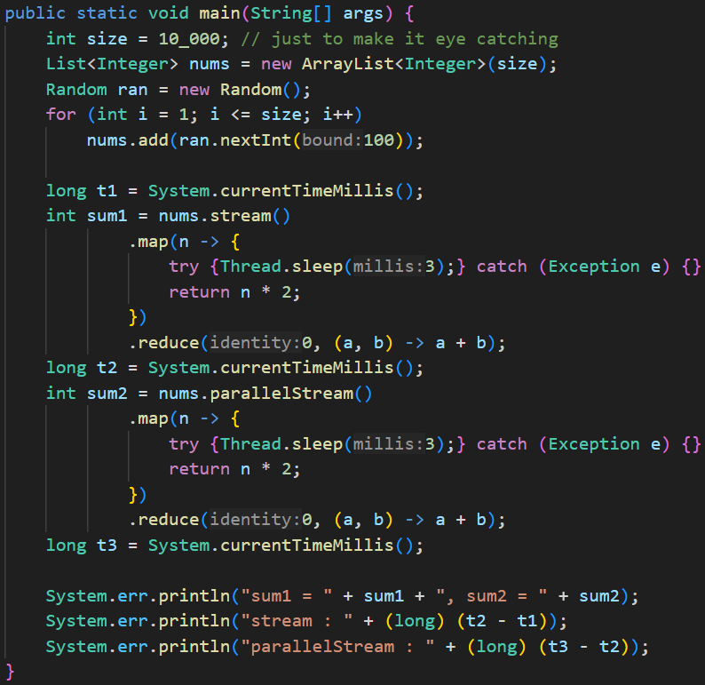
    - 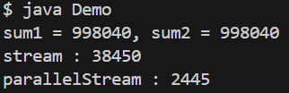
    - parallelStream ran faster (as multiple threads)
    - 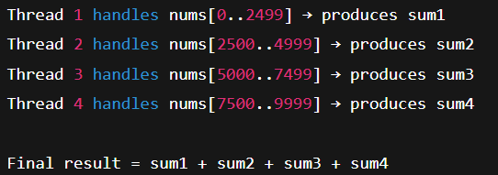(it works like this)

- Optional class
  - It’s a class just to avoid the Null Pointer Exception.
  - 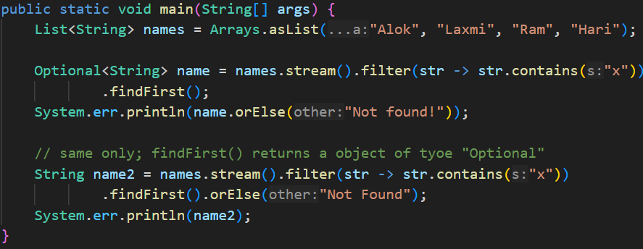

- Method Reference
  - 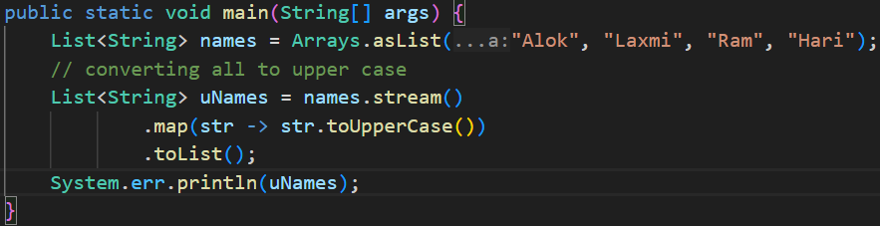
    - Here, in the lambda expression passed inside the map() method, we are just calling a method i.e. toUpperCase() present inside that object i.e. str.
    - So, when you are just calling a method of an object, no need to write the full lambda expression. Just pass the reference of that method.
    - 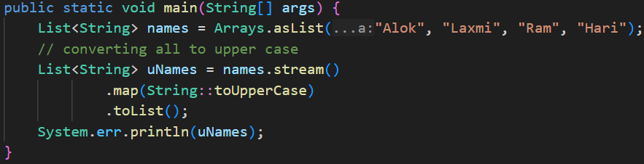
    - :: is used to reference a instance method of a class.
  - Now the confusion is: in both the cases, it is acting differently.
    - In first case, its calling that method using the str i.e. str.toUpperCase()
    - But in second case, its calling that method using the object (System.out) provided and passing the str inside it.

    - NOTE
    - If the reference is in the form ClassName::methodName, the method is called on the object provided by the function (e.g., str.toUpperCase()).
    - If the reference is in the form objectName::methodName, the method is called on that object, with the function-provided value passed as an argument (e.g., System.out.println(str)).

- Constructor Reference
  - 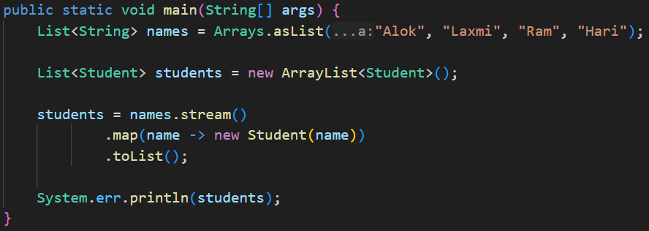
    - Here, I am creating a ArrayList of type Student, from a List of type String, using map function.
  - 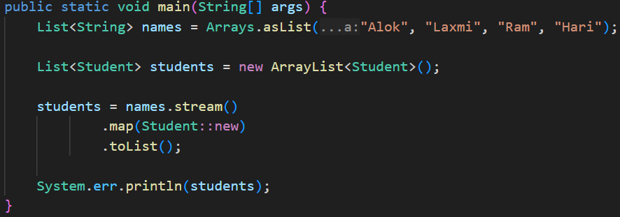
    - It’ll do the work.

- Supplier interface
  - It is a functional interface that provides a get method to create something.
  - 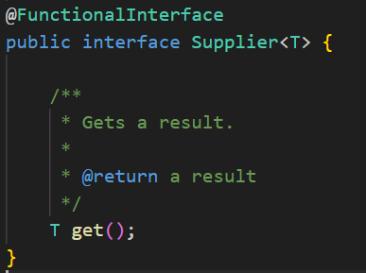
  - 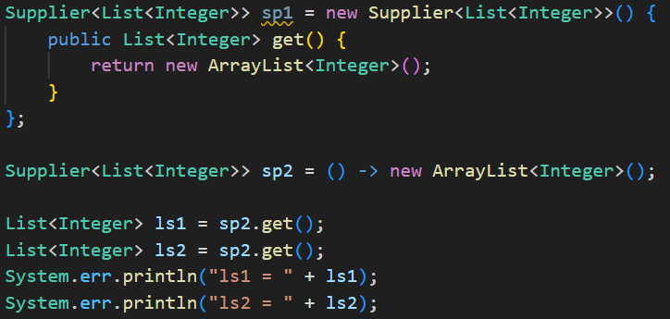
    - Here, I used sp2 to create 2 ArrayList<Integer>
    - 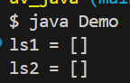
  - 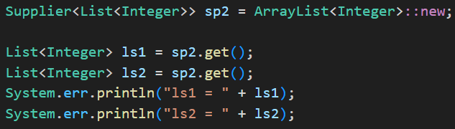
    - It can also be written like this using the Constructor reference.

- NOTE:
  - If you don’t specify the type in array list, it’ll take that as raw type. Means different data type values can be added in the ArrayList.
    - 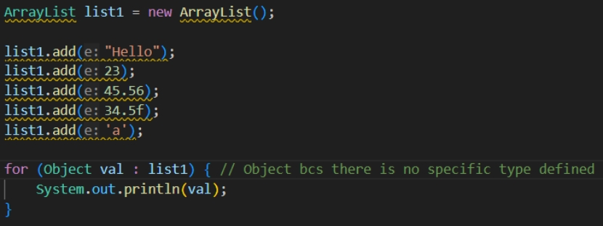
    - 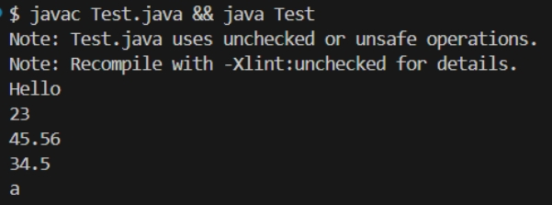

Reflection in Java
- Lets say we have created one object of a class. When we call the method getClass() it’ll return the class object of the class out of which the object is created.
  - For example: lets say the class name is Car and we created one object carObj.
  - carObj.getClass() will give the object which is Car.class
  - Car.class is the class object of Car class.
- The class object is used for reflection.
- Reflection means inspecting/modifying classes at runtime.
  - Reading fields
  - Modifying fields
  - Invoking methods
  - Listing constructors
  - Creating objects dynamically
  - Reading annotations
- Sometimes you’ll get some object at runtime, but you don’t know which class does that belong to.
  - In that case you can use ? type generic
  - 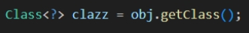
  - 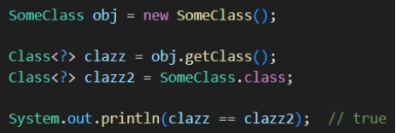
- There are 2 fields: getField() and getDeclaredField()
  - getField()
    - It cannot access private or protected fields.
    - It searches for the field in super classes as well.
  - getDeclaredField()
    - It can access all type of fields.
    - It doesn’t search in super classes.
  - In the class, name is a private field of type String.
  - getField() will not be able to get this. But getDeclaredField() can access this.
- 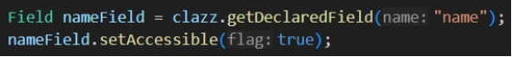
  - Now, I extracted the field name from the class using getDeclaredField()
  - Then I set it accessible using setAccessible(true) method.
  - NOTE: setAccessible(true) doesn’t mean you are making the field public. It just allows you to read/write after getting it.
  - 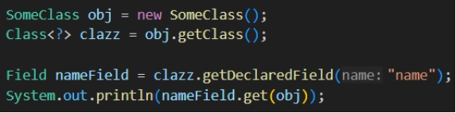
    - This will give error because the name field is private.
  - 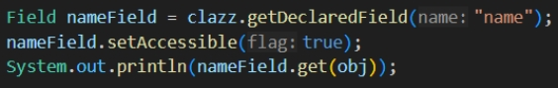
    - Now it can be accessible because we made it accessible using the method setAccessible.
- I have written 2 private methods in the class named as display and randomMethod
  - 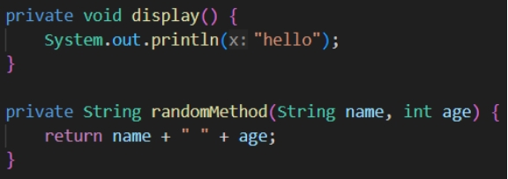
    - Both are private
  - 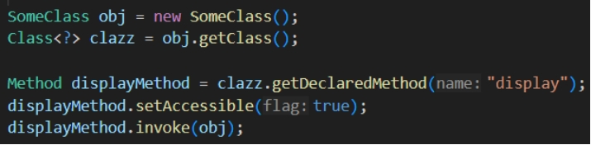
    - Here I am getting the display method using the function getDeclaredMethod() and making it accessible
    - Then invoke means it’ll run the function. You need to pass the instance of the class as it’s a non static method.
  - 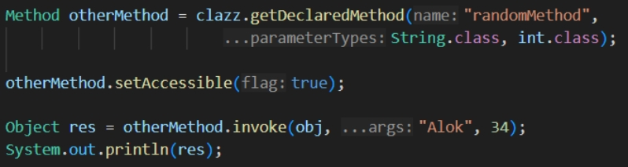
    - As the other method is returning something and also it has some arguments, so we need to pass the class object of all the arguments.
      - Here String.class, int.class
    - And the invoke method returns a Object type value so the res is of type Object.
    - We can also downcast here.
      - 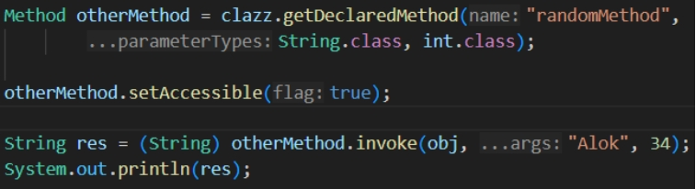
- Reflection in Spring
- Spring uses reflection to inspect classes, discover annotations, create objects, inject dependencies, and call methods — all at runtime.
- Dependency Injection
  - 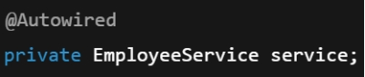 (we write like this)
  - 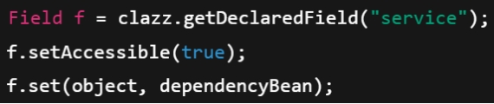 (internal of spring)
- Reading Annotations
  - 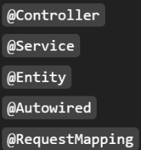 (we write these)
  - 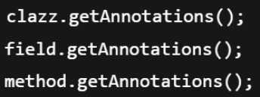 (spring does this)
- ReflectionUtils is a Spring utility class that makes using Java Reflection easier, safer, and cleaner.
  - Java Reflection = raw, low-level, verbose
  - Spring ReflectionUtils = wrapper that simplifies reflection
- Comparision
    - Spring ReflectionUtils
    - Java Reflection
- Some advantages of Spring ReflectionUtils over Java Reflections
  - It handles exceptions by itself
  - It marks setAccessible(true) by default
  - Handles super class traversal as well.
  - Provides iteration helpers
    - 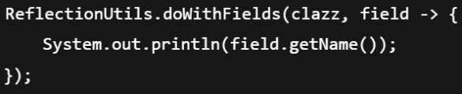

- F

synchronized
- It is used to lock class, object, instance method, static method to make those thread safe.
- Synchronized block with Class object.
  - 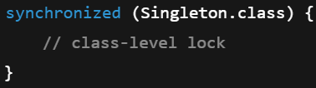
  - It is class level, not object level
- Synchronized block with objects
  - Synchronized block with this (lock itself)
    - 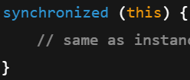
    - It is object level
  - Synchronized block with 3rd party object (lock another object)
    - 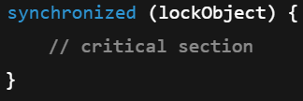
    - here lockObject is another object
      - 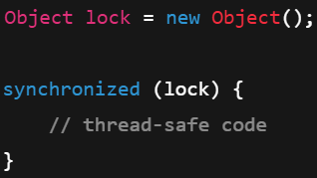
- Synchronized instance method
  - Method can be called once at a time.
  - 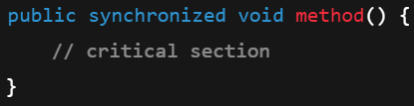
- Synchronized static method
  - Static method can be called once at a time
  - 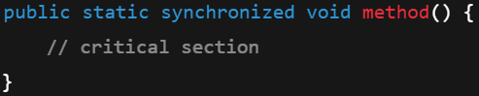
- this vs 3rd party object synchronized
  - this
    - 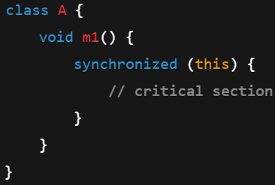
      - Here it is using this means this object (object of A) itself will be locked.
      - So, if a thread has called obA.m1() then no other method can use obA ; different instance of Account can be used.
    - 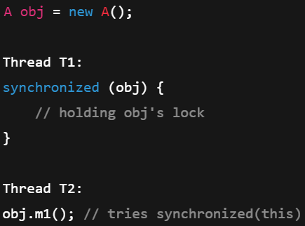 (pseudocode; not syntax)
      - Here, T2 will not run, as obj.m1() requires the lock on this object obj itself, but it is locked by T1,
  - lockObject
    - 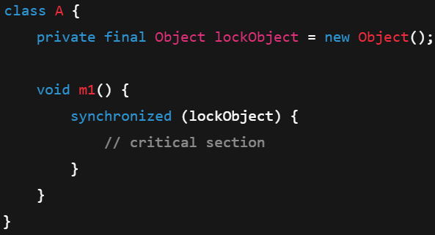
      - Here, lockObject (3rd party object present inside class A) is only locked, but obA can be used by other threads as this is not locked.
    - 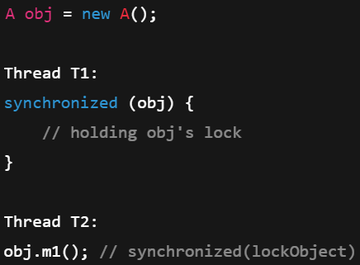
      - Here, T2 will run because obj.m1() requires lock on lockObject, and T1 has locked obj.
      - obj is object of class A; lockObject is a object present inside class A;

- There is a keyword called volatile in Java.
  - (Stripe class)
  - volatile make sure that if one thread changes the variable, then other thread will immediately sees that.
  - If you think, both the threads contains the same reference of variable, then you are wrong.
    - 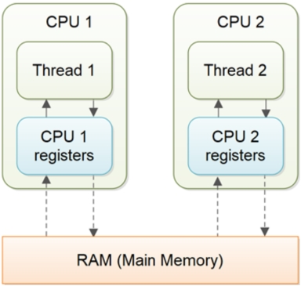
    - 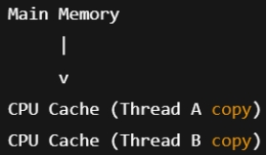
this is how execution happens, both thread has their own copy of cache where the variable is stored.
And when it is made volatile, both take reference from the main memory directly.
  - Consider the below example:
    - 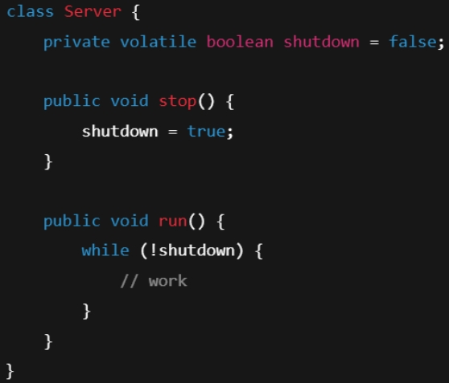
    - 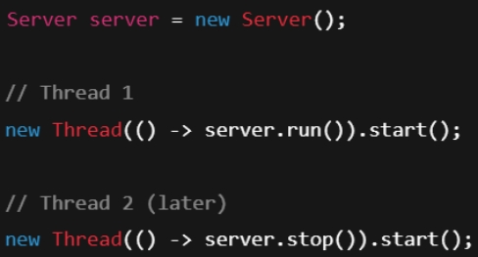
    - thread-1 is calling run, thread-2 is calling stop, if the variable was not volatile, it’d not stop the thread-1.

- F
- F
- F

